Theoretical definitions

The first part requires proving that set difference of recursive sets is recursive, while the second part examines if this property extends to recursively enumerable (r.e.) sets.

Part 1: Proving A \ B is recursive when A and B are recursive

Since A and B are recursive, their characteristic functions χA and χB are computable. We can construct the characteristic function for A \ B as:

χA\B(x) = χA(x) · sg(χB(x))

where sg is the complement sign function (sg(0) = 1 and sg(1) = 0), which we know is computable.

Since χA\B is constructed through composition of computable functions, it is computable. Therefore, A \ B is recursive.

Part 2: Examining if the property extends to r.e. sets

This property does not extend to r.e. sets. We can prove this with a counterexample:

Let A = K (the halting set) and B = N (the set of natural numbers). Both A and K are r.e.:

* K is known to be r.e. but not recursive
* N is recursive (thus also r.e.)

However, A \ B = K \ N = ∅

If K \ N were r.e., then K would be recursive, since: x ∈ K iff x ∉ (K \ N) = x ∈ K

This would mean both K and K are r.e., implying K is recursive. However, this contradicts the known fact that K is not recursive.

Therefore, A \ B is not r.e., providing a counterexample to show that set difference of r.e. sets is not necessarily r.e.

Part 1: If f,g are computable → Qf,g is semidecidable

Since g is computable, there exists e ∈ N such that g = φe. We can express:

Qf,g(x) ≡ "f(x) = g(x)" ≡ "f(x) = φe(x)" ≡ ∃t. S(e,x,f(x),t)

where S(e,x,z,t) is the decidable predicate "φe(x) halts with output z in t steps or less".

Since f is computable and S is decidable, by the Structure Theorem, Qf,g is semidecidable.

Part 2: If Qf,g is semidecidable → f,g computable

The converse does not hold. Consider the predicate:

Qf,g(x) ≡ "φx(x)↑"

where g is not computable but the predicate "g(x)↑" is decidable. By the Projection Theorem, if Qf,g were semidecidable, its negation would also be semidecidable, which would make K = {x | φx(x)↓} recursive - a contradiction.

Therefore, the semidecidability of Qf,g does not imply that both f and g are computable

Exercise 7.11:

No, such an index x cannot exist. Let's prove this by contradiction.

Suppose there exists x ∈ N such that K̄ = {y² - 1 : y ∈ Ex}. Since K̄ is not recursively enumerable (r.e.), but {y² - 1 : y ∈ Ex} is r.e. (as it's the image of a computable function on an r.e. set), we immediately reach a contradiction.

To see why {y² - 1 : y ∈ Ex} is r.e., observe that:

1) Ex is r.e. by definition (it's the image of a partial recursive function)

2) The function f(y) = y² - 1 is computable

3) The image of an r.e. set under a computable function is r.e.

Therefore, such an index x cannot exist as it would imply K̄ is r.e., which contradicts a fundamental result in computability theory.

Exercise 7.12:

Let's prove both directions of the equivalence.

(⇒) Assume f is computable. Then:

- The function h(x) = π(x,f(x)) is computable as composition of computable functions

- Af = img(h) = {π(x,f(x)) : x ∈ N}

- Since Af is the image of a computable function, it is r.e.

(⇐) Assume Af is r.e. Then:

- Let sc_A be the semicharacteristic function of Af

- We can define f(x) = (μz.∃w. π(x,z) ∈ Af)

- More formally: f(x) = (μz.sc_A(π(x,z)))₁

- Since π is injective and Af is r.e., this function is computable

- This gives us exactly f(x), as π(x,y) ∈ Af if and only if y = f(x)

Therefore, f is computable if and only if Af is r.e.

(⇒) Assume A is recursively enumerable. Then by definition, there exists a computable function sc_A that semi-characterizes A. Consider an enumeration of prime numbers P = {p₁, p₂, p₃, ...}. We can define g : N² → N as:

g(x,y) = y·1(sc_A(x))

This function is computable since sc_A is computable. By the smn theorem, there exists a total computable function s such that φₛ(ₓ)(y) = g(x,y) for all x,y ∈ N.

Now define f(x) = μy.H(s(y),x,y) where H is the halting predicate. The function f has domain P (the set of prime numbers) and img(f) = A because:

- If x ∈ A then sc_A(x)↓ so there exists a prime p where f(p) = x

- If x ∈ img(f) then x must be in A since sc_A(x)↓

(⇐) Assume there exists f with dom(f) = P and img(f) = A. We need to show A is recursively enumerable. Define:

sc_A(x) = 1(μz.S(e,π₁(z),x,π₂(z)))

where e is an index for f, S is the step predicate, and π₁,π₂ are the projection functions. This function is computable since:

- The step predicate S is decidable

- The projections are primitive recursive

- Minimalization preserves computability

Moreover:

- If x ∈ A then x ∈ img(f) so there exists a prime p where f(p) = x, hence sc_A(x)↓

- If sc_A(x)↓ then x must be in img(f) = A

Therefore sc_A semi-characterizes A, showing A is recursively enumerable.

Not computable functions

Assume, for contradiction, that f is computable. Then we can define:

χ_T(x) = sg(|f(x) - (φ_x(x) + 1)|)

where T = {x | φ_y(y)↓ for each y ≤ x} is the set of indices where all smaller indices halt.

However, χ_T would correctly characterize T since:

* If x ∈ T, then φ_y(y)↓ for all y ≤ x, so f(x) = φ_x(x) + 1, thus χ_T(x) = 1
* If x ∉ T, then there exists y ≤ x where φ_y(y)↑, so f(x) = 0, and thus χ_T(x) = 0

But T is not recursive (this can be proven by reduction from K). Therefore χ_T cannot be computable, contradicting our assumption that f was computable.

Therefore, f is not computable.

Assume, for contradiction, that there exists a non-computable function f : N → N such that D = {x ∈ N | f(x) ≠ φ_x(x)} is finite.

Let D = {x₁, x₂, ..., x_n} be this finite set. Since D is finite, we can define a new function g : N → N as:

g(x) = {

φ_x(x) + 1 if x ∈ D

f(x) if x ∉ D

}

This function g would be computable because:

1) For x ∈ D (which is finite), we can compute φ_x(x) + 1 using the universal function

2) For x ∉ D, we know that f(x) = φ_x(x), so g(x) = φ_x(x)

3) Testing if x ∈ D is decidable since D is finite

However, by construction:

- For x ∈ D: g(x) = φ_x(x) + 1 ≠ φ_x(x)

- For x ∉ D: g(x) = f(x) = φ_x(x)

Therefore g = f, which means f would be computable, contradicting our initial assumption.

Therefore, no such non-computable function f can exist where D is finite.

Smn-theorem

First, let me state the s-m-n theorem (smn theorem):

For any m,n ≥ 1, there exists a total computable function s_m,n : N^(m+1) → N such that for all e ∈ N, x⃗ ∈ N^m, y⃗ ∈ N^n:

φ^(m+n)_e(x⃗,y⃗) = φ^(n)_(s_m,n(e,x⃗))(y⃗)

Now, for the proof that there exists a total computable function s: N² → N such that |W_s(x,y)| = x*y:

Let's define an auxiliary two-argument computable function g(x,y,z):

g(x,y,z) = {

0 if z < x*y

↑ otherwise

}

This function is computable since it can be written as:

g(x,y,z) = 0 + μw.(z + 1 - x*y)

By the smn theorem, there exists a total computable function s : N² → N such that for all x,y,z ∈ N:

φ_s(x,y)(z) = g(x,y,z)

Therefore:

- For any x,y ∈ N, W_s(x,y) = {z | g(x,y,z)↓} = {z | z < x*y}

- Thus |W_s(x,y)| = x*y

This function s has the required properties:

1) It is total and computable (by the smn theorem)

2) For all x,y ∈ N, |W_s(x,y)| = x*y (by construction)

Therefore, we have proven the existence of the required function s.

First, let me state the s-m-n theorem:

For any m,n ≥ 1, there exists a total computable function s_m,n : N^(m+1) → N such that for all e ∈ N, x⃗ ∈ N^m, y⃗ ∈ N^n:

φ^(m+n)_e(x⃗,y⃗) = φ^(n)_(s_m,n(e,x⃗))(y⃗)

Now, for the proof that there exists a total computable function k: N → N such that φ_k(x)(y) = lcd(x,y):

Let's define a computable function g(x,y) that computes the least common multiple:

g(x,y) = μz ≤ x*y.(x|z ∧ y|z)

This function is computable since:

1) The "divides" relation (x|z) is decidable

2) The bound x*y ensures the minimalization is bounded

3) The composition of these operations preserves computability

By the smn theorem with m=1 and n=1, there exists a total computable function k : N → N such that for all x,y ∈ N:

φ_k(x)(y) = g(x,y)

Therefore:

1) k is total and computable by the smn theorem

2) For all x,y ∈ N, φ_k(x)(y) = g(x,y) = lcd(x,y) by construction

3) k satisfies the required property φ_k(x)(y) = lcd(x,y)

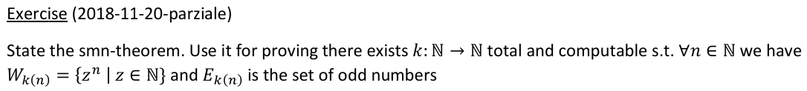This completes the proof of the existence of the required function k.

Primitive recursion

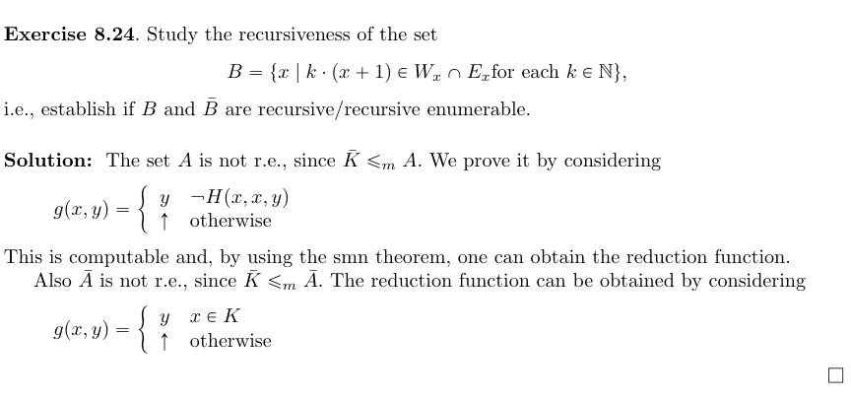Recursiveness

Exercise 8.37:

First, let's prove that V is not recursive by showing that K ≤m V.

To establish this reduction, let's define function g(x,y):

g(x,y) = {

1 if x ∈ K

↑ otherwise

}

This function is computable since g(x,y) = scK(x). By the s-m-n theorem, there exists a total computable function s: ℕ → ℕ such that φs(x)(y) = g(x,y) for all x,y ∈ ℕ.

We can show s is a reduction function from K to V:

1) If x ∈ K, then φs(x)(y) = 1 for some y. Therefore Ws(x) = {1}, and 1 = 1·s(x), so s(x) ∈ V.

2) If x ∉ K, then φs(x)(y)↑ for all y. Therefore Ws(x) = ∅, and there are no y,k such that y = k·s(x), so s(x) ∉ V.

Since K ≤m V and K is not recursive, V is not recursive.

Additionally, V is recursively enumerable since:

scV(x) = 1(μw.(H(x,(w)1,(w)3) ∧ (w)2·x = (w)1))

Therefore V is r.e. but not recursive, so V̄ is not r.e.

Exercise 8.38:

This set is saturated since V = {x | φx ∈ A} where A = {f | |dom(f)| > 1}.

We can use Rice-Shapiro theorem to prove both V and V̄ are not r.e.:

1) V is not r.e.:

Consider id ∉ V and θ ⊆ id where θ(x) = x for x ≤ 1. Then θ ∈ V since |dom(θ)| = 2 > 1, and θ is finite. By Rice-Shapiro theorem, V is not r.e.

2) V̄ is not r.e.:

Consider the constant function 1 ∉ V̄ (since its domain is infinite). Let θ ⊆ 1 where θ(0) = 1. Then θ ∈ V̄ since |dom(θ)| = 1, and θ is finite. By Rice-Shapiro theorem, V̄ is not r.e.

Therefore, V is neither recursive nor r.e., and V̄ is not r.e.

Second recursion theorem

